## [History of social classes and does class matter?](https://stephenliddell.co.uk/2013/04/06/history-of-social-classes-and-does-class-matter/)

Posted on [April 6, 2013](https://stephenliddell.co.uk/2013/04/06/history-of-social-classes-and-does-class-matter/) by [Stephen Liddell](https://stephenliddell.co.uk/author/stephenliddell/) <https://stephenliddell.co.uk/2013/04/06/history-of-social-classes-and-does-class-matter/>

(Shortened version and glossary by Rikke Rosendahl Schmidt, Viby Gymnasium og HF)

[…]

Britain is famous for its class system. This is largely due to our long history without internal revolutions or wars. France underwent its revolution which largely rid it of its upper class. Germany lost its when the Nazi’s found Aristocrats to be a hindrance to its social engineering and world domination. Russia and China underwent Communist revolutions in the 20th C, and Italy, Spain, Austria-Hungary and many others either suffered from fascism or war and often both.

[…]

Traditionally we were split into three classes. The Upper Class or ruling elite who are closely aligned to the Monarchy and landed gentry[1], the middle class who were people such as doctors and solicitors who did have wealth but not “good breeding” and the working class who has Marx deduced in the 19th Century provided their labour but did not own any means of production.

[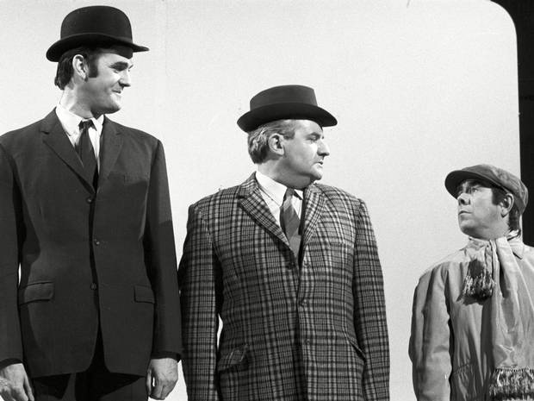](https://stephenliddell.files.wordpress.com/2013/04/social-classes.jpg)

The famous comedy sketch illustrating the three traditional classes.

Class was only ever partially related to money. Unlike in countries like the United States where money and star status meant individuals were considered to be at the top of society, here it was mostly due to family ancestry. Though not common, it was entirely possible for an Aristocratic family to be almost bankrupt whilst retaining their upper-class rating that middle class families with more money or assets could never hope to gain.

Overt displays of wealth were and to a degree still are seen as vulgar. True breeding[2] meant one didn’t have to show off. As an example someone like Prince Charles is often seen in the country in old clothes that the average unemployed person would never dream of being seen out with.

[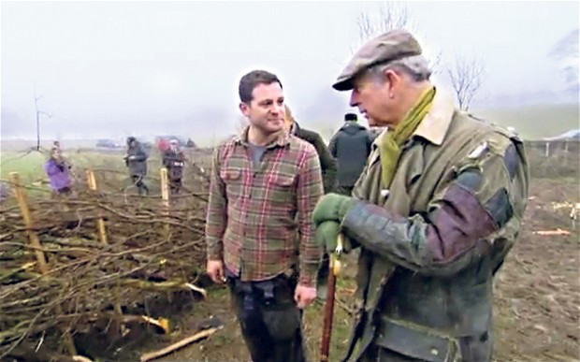](https://stephenliddell.files.wordpress.com/2013/04/prince-charles.jpg)

Prince Charles doing a good impression of a country bumpkin[3]

Whilst someone like David Beckham might have millions of pounds but will only ever be seen as Middle-Class at best and often no more than a jumped up working-class. The more people like him show off their wealth and glamour with tacky though hugely expensive weddings and try to stress their credibility, the more the real upper class will turn up their noses. Just witness Downton Abbey[4] for evidence of this. It is often said that the truly rich don’t have any need or desire to show off their wealth whereas the new money is always trying to show it and impress those they have left behind.

[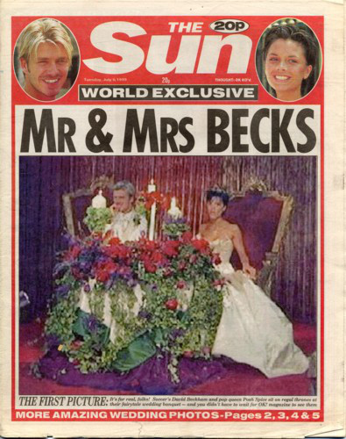](https://stephenliddell.files.wordpress.com/2013/04/06-posh_becks_wedding.jpg)

Stylish and rich or just Uber-tacky?

Whilst the Industrial Revolution[5] and world trade led to the rise of what would now be thought of Middle-Class with Industrialists and entrepreneurs setting up businesses and corporations, it wasn’t until the late 19th Century that workers identified themselves as working class. Whilst the Liberal Party did much to improve the plight of the poor before WW1 it was not until the 1920s that the working class got their act together as a political force.

[…]

Whatever is said, class still matters. The vast majority of land and wealth belong to the descendants of a few hundred Norman invaders from 1066[6]. They go to the most expensive private schools and prestigious universities, run most political parties and even take more than their share best or high-profile jobs. It’s surprising for example just how many television stars are from what would be considered upper class backgrounds. […]

These days […] wealth is not the only defining factor in what class you are. It is quite easy for a very poor working class person to enjoy classical music or read philosophy whilst just yesterday, George Osborne the second most important politician in the U.K. a millionaire and from an Aristocratic background was spotted coming out of McDonalds, something most middle-class folk would never dream of doing, or at least get caught visiting. Despite his hugely wealthy and powerful family background, Gideon George Oliver Osborne was still labelled as an ‘oik’[7] by his university colleagues who were even more well-bred and who form the basis of our government and leading business and economic institutions.

Other things that give away class include clothing, hobbies and even words. Not just accents but the actual words themselves. This was highlighted by the famous book “U and non-U” meaning Upper Class and none Upper Class with some examples below.

|  |  |
| --- | --- |
| **Upper Class** | **Non-Upper Class** |
| ***Vegetables*** | **Greens** |
| **Lavatory** *or* **Loo** | **Toilet** |

This week though as a result of a study of over 160,000 people it has been announced that there are now 7 social classes. This takes into account various factors such as friends, social media, hobbies, job status and of course wealth. [You can try the test for yourself here](http://www.bbc.co.uk/news/magazine-22000973)

Below are a number charts that indicate the new typical classes.

[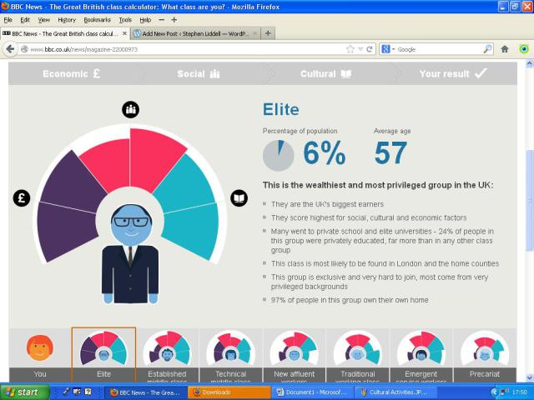](https://stephenliddell.files.wordpress.com/2013/04/elite.jpg)

At the top is the Elite. They have money, good connections and highly cultured.

[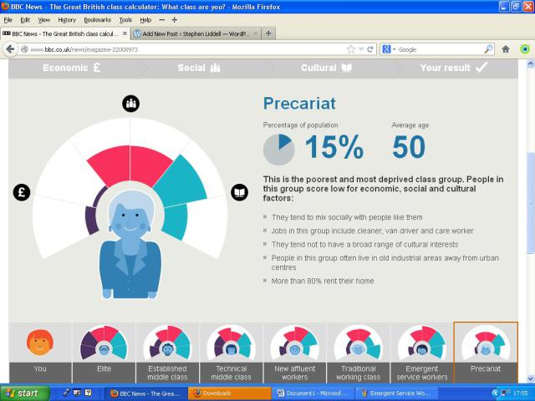](https://stephenliddell.files.wordpress.com/2013/04/precariat.jpg)

The unfortunate 15% of society who are continually poor and deprived.

An important factor in the economic health and vibrancy of a nation is the extent to which one can change their social status. In the United States this is what is known as the American Dream. The idea that someone can arrive in the USA penniless and either work their way up themselves or in a generation or two.

[…]

The fact is that only 39% of the population are now in the traditional 3 classes but the modern political parties are continuing to argue amongst themselves in the same way. No wonder people are disaffected with politics as they are not being represented and funnily enough the percentage of people who are voting in elections isn’t too far from 39% either.

Class may not be as important as it once was but it still is important whether people realise it or not.

1. <http://ordnet.dk/ddo/ordbog?query=landadel>
2. At komme fra en god familie
3. Bonderøv
4. <http://www.itv.com/downtonabbey>
5. <http://www.history.com/topics/industrial-revolution>
6. <https://www.britannica.com/event/Norman-Conquest>
7. En øretæveindbydende person (slang)