Sustainability – AN – 2019

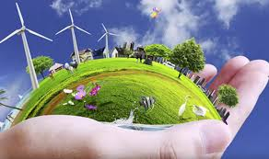

Contents:

p. 2 Researching the term

p. 3 UN Sustainable Development Goals

Copenhagen Consensus Project

pp. 4-5 Useful glossary

p. 6 8 stations on Sustainability

pp. 7-12 The Larder

pp. 13-17 The Carbon footprint

pp. 18-19 Scientists Are Radically Changing…

pp. 20-21 New technologies are helping

p. 22 Documentary: Minimalism

Bibliography:

UN: ”UN Sustainable Development Goals”, <https://sustainabledevelopment.un.org/?menu=1300>

Copenhagen Consensus Center: ”The smartest targets for the world”, <https://docs.wixstatic.com/ugd/b7d215_9ecadc79bc58456aa84490283b5d2171.pdf>

Morris Lurie: ”The Larder”, 1984 in Grønvold: Footprints, Gyldendal, 2017

Mike Berners-Lee and Duncan Clark: ”Carbon footprints”,, 4 June, 2010, The Guardian in Grønvold: Footprints, Gyldendal, 2017

Zahra Hirji: ”These Scientists Are Radically Changing How They Live To Cope With Climate Change”, April 23, 2019, <https://www.buzzfeednews.com/article/zahrahirji/scientists-climate-change-action> (edited version)

Alex Gray: ”New technologies are helping to fight global warming”, 09 Jan 2017, World Economic Forum, <https://www.weforum.org/agenda/2017/01/tech-innovations-save-us-from-climate-change/>

[Matt D'Avella](https://www.imdb.com/name/nm6576361/?ref_=tt_ov_dr): Netflix documentary: Minimalism, 2016, <https://www.netflix.com/title/80114460>

Researching the term

1. Individual work: Find as much information as you can in 15 minutes on the concept of ‘sustainability’ and the UN Sustainable Development Goals
2. Individual work: take notes while researching the topic
3. Share and discuss your findings in your group
4. The scribe writes down three important statements from your discussion
5. The speaker presents the statements in class and explains why they are important

NB! All tasks used in this compendium are based on a group role structure that can be found here: <https://docs.wixstatic.com/ugd/b7d215_0603abcfed8d48b19b09c6b8afb0cdf5.docx?dn=team%20roles.docx>

Here are the UN Sustainable Development Goals:

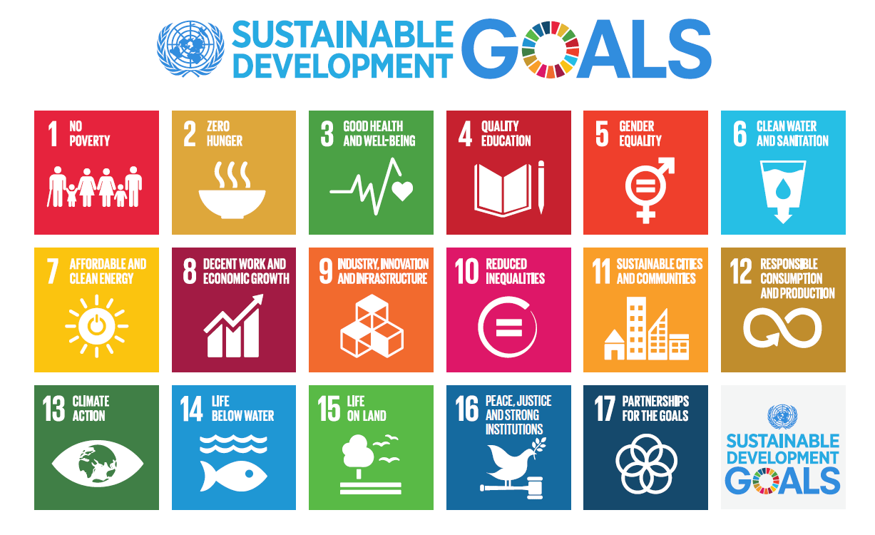

We can all agree that they are important goals, but resources are limited.

a)

You only have 100 ’coins’ available. It is your task to assign ’coins’ to each goal according to what you believe is the most important. So if you spend 40 ’coins’ on 1 NO POVERTY, you only have 60 ’coins’ left to deal with the rest of the goals.

You must be able to explain your choices.

Remember your team roles.

b)

You’ve now prioritized the goals. Let’s see if your favourites are also financially sound.

Compare the financial gains in this chart from the Copenhagen Consensus Project with your own list: <https://docs.wixstatic.com/ugd/b7d215_9ecadc79bc58456aa84490283b5d2171.pdf>

Does it change anything for you? Why/why not?

Again: Remember your team roles.

Building vocabulary (Footprints task - modified by AN)

The words in the chart are very useful for your work with the theme of sustainable development. Fill out as many of the empty boxes as you can.

NB! ”------------------” indicates that there is no corresponding verb.

|  |  |  |  |
| --- | --- | --- | --- |
| **English noun** | **Danish translation of English noun** | **English adjective** | **English verb** |
| poverty | fattigdom | poor | ------------------ |
| economy | økonomi | economic |  |
| impact |  |  | Impact |
| emission | udledning |  | Emit |
| increase |  |  | Increase |
| significance |  | significant |  |
| solution |  |  | Solve |
| cause |  | causal | Cause |
| decision |  | decisive |  |
| rise |  | rising | Rise |
| responsibility |  | responsible | ------------------ |
| pollution |  |  | Pollute |
| globalisation |  |  |  |
| development |  | developed developing |  |
| sustainability |  | sustainable | Sustain |
| globe |  | global | ------------------ |
| exploitation | udnyttelse |  | Exploit |
| limit |  | limiting/limited |  |

Building vocabulary

1. The scribe opens wordjuggle.com and signs in as a student
2. Create a new category with your names as the category name
3. Your class code is FG03
4. Based on the 18 English nouns from task 3, you set up 18 sets of word/definition. Write your own definitions. Do NOT copy from dictionaries, but it’s ok to find inspiration in dictionaries
5. Choose and print a game based on your words/definitions that you want the other groups to play

8 stations on Sustainability (Footprints task - modified by AN))

The stations are based on the UN’s Sustainable Development Goals. Visit as many stations as possible in 90 minutes – findings are to be shared in matrix groups.

The tasks can be found here: <https://docs.wixstatic.com/ugd/b7d215_f4b8041cdf0f4a0d84ec1b395bb085d5.pdf>

1. Read ”The Larder”

(You may find the story with a glossary in Footprints on pp. 91-94)

**The Larder**

Morris Lurie (1984)

*'Larder of the earth, the sea. Man’s richest feeding ground.'*

The people who didn’t go to the reef crowded around to see what the others had brought back. ‘My goodness,’ said one of the old ladies who hadn’t gone (she had come for a rest, and was a little bit frightened of boats and water and all that stepping up and down), ‘what are they?’ She peered down at one of them, blinking. It lay on its back, on the grass, the creature tucked up inside its shell, only the tip of its claw visible, quite harmless, but the old lady wouldn’t touch it. Some of the others were crawling about on the grass. The island dog sniffed at them and barked. ‘Aren’t they beautiful?’ said the people who had brought them back, pushing them with their feet when they tried to creep away too far, out of the circle of light. Forty people had gone to the reef, and they had brought back almost a hundred shells. The tide was in, so the boat had been able to tie up at the quay, and they had stepped straight ashore, laughing, flushed with sun, exhausted, the usual tourists. When the tide was out, you were brought in by flat-bottomed barge, a slow and tiring business. The tide went out almost half a mile. It was night now, quite dark. The bells for dinner sounded through the trees. ‘Is it safe to just leave them here?’ the people who had brought them back wanted to know, because they were hungry and wanted to go in for dinner. ‘Safe as houses,’ said the guide. ‘Turn them over, they won’t get far.’ So they turned them over and left them there on the grass, some of them wriggling, most of them still, with the island dog sniffing and growling and running around them in the night.

They talked about them over dinner, proudly. ‘Oh, I brought back nine,’ one of them said. He laughed. He was a real-estate agent with a huge face, loose jowls, shaggy eyebrows, his shirt open at the throat and his corduroy jacket loosely thrown over his shoulders, leaving his arms free while he ate. ‘Don’t know what the hell I’m going to do with them all, but there they were, free for the taking, you can’t pass up a chance like that. Damn rare. Chance of a lifetime. God knows when I’ll be in these parts again. Well, see that lady over there? – with the glasses? She brought back twelve. Love to see her getting all those home, ha ha. One of them about the size of this table.’ ‘Really?’ said a lady who hadn’t gone. She was a schoolteacher. ‘That big?’ ‘Naah,’ said the real-estate agent, laughing, his mouth full of food. ‘I’m joking. But pretty big, all the same. About like this.’ He showed her with his hands. She narrowed her eyes and shook her head. ‘What are they exactly? What are they called?’ she wanted to know. ‘Don’t ask me,’ said the real-estate agent. ‘Beautiful things, though. When you turn them over. Smooth as silk. You have to take the things out of them though, otherwise they really stink up the place.’

They had crawled quite far in the morning, some of them off the grass and onto the gravelpaths, and a few of them even further and in amongst the trees, but they were all found and all brought back. The larger ones hadn’t moved at all, their silk-smooth purple and mauveunderside still pointed up to the sky. In some of them, the creature had come quite a way out, and you could see the pink of its body past the claw. But they all ducked back into their shells as soon as they were touched, except for the very tip of the claw, for which there was no room in the shell. They were lightning fast. They had already started to smell. A few of them looked dead.

The owners of the shells gathered around them, poking them with their feet, picking them up, turning them over, comparing shells, boasting of their own. But a few of them, seeing them now in the sun, appeared slightly embarrassed. They had brought back so many! Yesterday’s enthusiasm hung on a thread. In the bright morning sun, under the palms, you could see how ugly they were, spiky, as rough as rocks, crawling slowly on the grass. But their undersides, in the morning sun, were more beautiful than ever.

A few of them set straight to work to get the creatures out. The others watched, not knowing what to do. It was hard to get hold of the claw, and even when you did, it was impossible to pull the creature out. It hung on grimly, locked inside its shell. You could pull them out about an inch, no more. And once you let go, the creature would hastily withdraw, and that was that. It wouldn’t venture out again, unless you left it alone for over an hour.

‘Bastards, aren’t they?’ said the real-estate agent. He had sat himself down on the grass and had one in his lap and was scratching away at the creature with a long-bladed knife, trying to gouge it out. ‘That’s awfully cruel,’ said the schoolteacher, and shuddered. The real-estate agent laughed. ‘Naah,’ he said. ‘They don’t feel a thing. Larder of the earth, the sea. Man’s richest feeding ground. There’s plenty more where this came from, and getting this fella out won’t make any difference at all. Pity they’re not edible though.’ He continued gouging with his knife, squintingin the sun, enjoying his work.

It was impossible to get them out with knives and sticks. Someone tried a fishhook but that tore through the creature, which quickly withdrew, leaving a wet colourless smear on the shell. Wire was useless. Throwing them about on the grass didn’t do anything at all. Putting them in water to coax the creatures out and then using a knife was a waste of time. It was half-way through the morning and no one had succeeded in removing a single one.

But they kept at it, undaunted. They sat about on the grass, under the trees, smoking cigarettes and trying everything they could think of and calling out suggestions to each other. ‘Why not just leave them in the sun?’ someone suggested. ‘Let the antseat them out.’ ‘They’ll smell for months,’ was the reply to that.

Then someone hit upon an idea. Everyone gathered around him and he explained it. ‘Fishing line,’ he said. ‘Make a noose around the claw and then hang the shell up and the weight of it will drag the things out.’ He showed them how. In thirty minutes they had hung them all up. They hung them from shrubs and from low branches and from railings. Everywhere you looked there were shells hanging. The method began to work at once. You could see the shells inching down to the ground, the creatures stretching, more and more of them coming out, pink in the sun. In ten minutes, some of them had pulled out as much as six inches, thin and pink, with the shell swaying under them. The owners of the shells watched, fascinated, until the bells rang for lunch, and then they went off to wash their hands and to eat.

All through lunch you could hear the shells dropping, plop, plop, softly on to the grass, regularly, one after another. You could see them lying on the ground through the windows of the dining room, like coconuts, except for the spikes. And you could also see those that hadn’t yet dropped, hanging low, the creatures stretched to a foot and more, the shells swaying and rocking under them though there was no wind.

The people who had hung them up were very happy at lunch. ‘There goes another!’ they called out, each time one fell to the ground. There was a lot of laughing and joking. They made bets to see which ones would drop first. The fishing line idea, they agreed, had been a stroke of genius.

By the time the main course arrived, they had all dropped. The grass was littered with shells. Those that had fallen with their undersides up shone in the sun. Most of them fell the other way, rough side up, the way they had looked on the reef, where you could hardly tell them from rock, except for the movement.

Then the birds came. They came just as the dessert was being served. They wheeled in the sky, scores of them, their wings flapping, screaming, crying, swooping down with their beaksopen, flashes of white and grey, with red legs and orange beaks. They came for the things on the fishing lines, hanging from the trees. You could smell the things through the open windows of the dining room, as rank as the sea, salty and foul. The attack of the birds was sudden and swift. It was all over before coffee.

After lunch, the people who had brought the shells back from the reef collected their shells and stacked them up outside their rooms, ready to take home with them. It was wonderful, they said, how cleanly the creatures had come out. The shells were not harmed at all.

They left the next morning, early, while the tide was still in. They took about twenty shells with them. They took only the smallest ones, those about the size of your hand. They were a good size, they said, for your mantelpiece. The others were ludicrous. They laughed, imagining them in their homes. Anyhow, they couldn’t possibly fit them all into their luggage. The shells they didn’t want they left outside their rooms. After the tourists had gone, the unwanted shells were pushed into a pile and thrown away, like the unwanted shells of the week before, and the week before that, and the week before that.

In the afternoon, a fresh boatful of tourists came in. They had come to swim and to drink and to laze in the sun. But already they were eager for their trip to the reef. They had been promised a treat. Their trip to the reef would take place on the day of the lowest tide of the year.

b)

Answer these questions in your group:

1. How many people have gone to the reef?
2. Why have they brought back almost a hundred shells?
3. Why are they described as “the usual tourists”?
4. What do the tourists do so the creatures won’t get away?
5. Why are the tourists proud?
6. What was “Smooth as silk … silk-smooth purple and mauve underside … pink body … ugly, spiky, as rough as rocks” as mentioned in preparation question 2?
7. Why has the real-estate agent brought back nine shells?
8. How big do you think the shells are?
9. Why does the real-estate agent use the word “things”:  
   *"'Don’t ask me,’ said the real-estate agent. ‘Beautiful things, though."*
10. In what ways is the schoolteacher’s attitude to the shells different from that of the realestate agent?
11. What is the difference between the two sides of the shell?
12. How do the tourists feel about the shells the following day?
13. Why does the schoolteacher shudder?
14. Which words would you use to characterize the real-estate agent and why?  
    *sympathetic – thoughtless – cruel – practical – sensible – matter-of-fact – naïve – ordinary – unusual – insensitive – stupid*
15. What do the tourists do to get the creatures out?
16. Why do the tourists agree that the fishing line method is a stroke of genius?
17. Why is the group happy at lunch?
18. What has happened by the time the main course arrives?
19. What happens when dessert is being served?
20. What was over before coffee?
21. Are the tourists who leave different from the tourists who arrive?
22. If you had been on the trip, would you have taken a shell? Why/why not?
23. Why do the tourists only take about twenty small shells with them?
24. Is the portrayal of tourists in this story fair? Why/why not?
25. What is the effect of the repetitions:
26. Why is the trip to the reef on the day of the lowest tide of the year a treat?
27. Explain the title.
28. What is the theme of the story?
29. How realistic do you consider this story to be?
30. In what way can the story be related to the concept of sustainability?
31. Is this story necessary in the 21st century? Why/why not?
32. Invent a question of your own.

c)

You now know the story quite well. Each student has a slip of paper with one question. Go up to a classmate, and ask the question. Wait for the answer and help your friend out if necessary. Then answer your friend’s question and switch slips. Continue the process till everybody has asked and answered most of the questions.

|  |  |  |  |
| --- | --- | --- | --- |
| **1.**How many people have gone to the reef? | **9.**In what ways is the schoolteacher’s attitude to the shells different from that of the real-estate agent? | **17.**What was over before coffee? | **25.**Why is the trip to the reef on the day of the lowest tide of the year a treat? |
| **2.**Why have they brought back almost a hundred shells? | **10.**What is the difference between the two sides of the shell? | **18.**Are the tourists who leave different from the tourists who arrive? | **26.**Explain the title. |
| **3.**Why are they described as “the usual tourists”? | **11.**How do the tourists feel about the shells the following day? | **19.**If you had been on the trip, would you have taken a shell? Why/why not? | **27.**What is the theme of the story? |
| **4.**What do the tourists do so that the creatures won’t get away? | **12.**Why does the schoolteacher shudder? | **20.**What has happened by the time the main course arrives? | **28.**How realistic do you consider this story? |
| **5.**Why are the tourists proud? | **13.**Which words would you use to characterize the real-estate agent and why? *sympathetic – cruel – thoughtless – practical – sensible – matter-of-fact – insensitive – ordinary – unusual – naïve – stupid* | **21.**What happens when dessert is being served? | **29.**What has the story got to do with sustainability? |
| **6.**Why has the real-estate agent brought back nine shells? | **14.**What do the tourists do to get the creatures out? | **22.**Is the portrayal of tourists in this story fair? Why/why not? | **30.**What was “Smooth as silk … silk-smooth purple and mauve underside … pink body … ugly, spiky, as rough as rocks” as mentioned in preparation question 2? |
| **7.**How big do you think the shells are? | **15.**Why do the tourists agree that the fishing line method is a stroke of genius? | **23.**Why do the tourists only take about twenty small shells with them? | **31.**Is this story necessary in the 21st century? Why/ why not? |
| **8.**Why does the realestate agent use the word “things”? | **16.**Why is the group happy at lunch? | **24.**What is the effect of the repetitions? |  |

Carbon footprint

1. Take this test to get an indication of your own personal footprint: <https://footprint.wwf.org.uk/#/>

But what exactly is a carbon footprint?

1. Watch this film: <https://www.youtube.com/watch?v=8q7_aV8eLUE>

and read ”What is a carbon footprint” below or in *Footprints* pp. 102-104 where you can find a glossary.

# Carbon footprints

By Mike Berners-Lee and Duncan Clark, 4 June, 2010, *The Guardian*

**A**  
Carbon footprint is a horribly abused phrase, so it’s worth spelling out exactly what it means.  
When talking about climate change, *footprint*is a metaphor for the total impact that something has. And *carbon*is a shorthandfor all the different greenhouse gases that contribute to global warming.  
The term *carbon footprint*, therefore, is a shorthand to describe the best estimate that we can get of the full climate change impact of something. That something could be anything – an activity, an item, a lifestyle, a company, a country or even the whole world.

**B  
CO2e? What’s that?**  
Man-made climate change, or global warming, is caused by the release of certain types of gas into the atmosphere. The dominant man-made greenhouse gas is carbon dioxide (CO2), which is emitted whenever we burn fossil fuels in homes, factories or power stations. But other greenhouse gases are also important. Methane (CH4), for example, which is emitted mainly by agriculture and landfill sites, is 25 times more potent per kilogram than CO2. Even more potent but emitted in smaller quantities are nitrous oxide (N2O), which is about 300 times more potent than carbon dioxide and released mainly from industrial processes and farming, and refrigerant gases, which are typically several thousand times more potent than CO2.  
In the UK, the total impact on the climate breaks down like this: carbon dioxide (86 %), methane (7 %), nitrous oxide (6 %) and refrigerant gases (1 %). Given that a single item or activity can cause multiple different greenhouse gases to be emitted, each in different quantities, a carbon footprint if written out in full could get pretty confusing. To avoid this, the convention is to express a carbon footprint in terms of carbon dioxide equivalent or CO2e. This means the total climate change impact of all the greenhouse gases caused byan item or activity rolled into one and expressed in terms of the amount of carbon dioxide that would have the same impact.

**C  
Beware carbon toe-prints**  
The most common abuse of the phrase carbon footprint is to miss out some or even most of the emissions caused, whatever activity or item is being discussed. For example, many online carbon calculator websites will tell you that your carbon footprint is a certain size based purely on your home energy and personal travel habits, while ignoring all of the goods and services you purchase.  
Similarly, a magazine publisher might claim to have measured its carbon footprint but in doing so looked only at its office and cars while ignoring the much greater emissions caused by the printing house that produces the magazines themselves. These kinds of carbon footprint are actually more like carbon ‘toe-prints’ – they don’t give the full picture.

**D  
Direct versus indirect emissions**  
Much of the confusion around footprints comes down to the distinction between ‘direct’ and ‘indirect’ emissions. The true carbon footprint of a plastic toy, for example, includes not only direct emissions resulting from the manufacturing process and the transportation of the toy to the shop: it also includes a whole host of indirect emissions, such as those caused by the extraction and processing of the oil used to make the plastic in the first place. These are just a few of the processes involved. If you think about it, tracing back all the things that have to happen to make that toy leads to an infinite number of pathways, most of which are infinitesimally small. To make the point clearly, let’s try following just one of those pathways. The staff in the offices of the plastic factory used paper clips made of steel. Within the footprint of that steel is a small allocation to take account of the maintenance of a digger in the iron mine that the steel originally came from … and so on for ever. The carbon footprint of the plastic toy includes the lot, so working it out accurately is no easy task.  
To give another example, the true carbon footprint of driving a car includes not only the emissions that come out of the exhaust pipe, but also all the emissions that take place when oil is extracted, shipped, refined into fuel and transported to the petrol station, not to mention the substantial emissions caused by producing and maintaining the car.

**E  
The essential but impossible measure**  
The carbon footprint, as I have defined it, is the climate change metric that we need to be looking at. The dilemma is that it is also impossible to pin down accurately. We don’t stand a hope of being able to understand how the impact of our bananas compares with the impact of all the other things we might buy instead unless we have some way of taking into accountthe farming, the transport, the storage and the processes that feed into those stages. So how should we deal with a situation in which the thing we need to understand is impossibly complex?  
One common response is to give up and measure something easier, even if that means losing most of what you are interested in off the radar. The illusionist Derren Brown refers to one of his core techniques as the misdirection of attention: by focusing his audience on something irrelevant he can make them miss the bit that matters. Examples include an airport waxing lyrical about the energy efficiency of its buildings without mentioning the flights themselves.  
The same thing can happen by accident. If you settle for a toe-print, there is a very good chance it will misdirect your attention away from the big deals. An alternative response to the dilemma, and the approach that this book [*How Bad Are Bananas? The Carbon Footprint of Everything*] is all about, is to do the best job you can, despite the difficulties, of understanding the whole picture. My work is about making the most realistic estimatesthat are possible and practical, and being honest about the uncertainty.

1. (Task from Footprints)

After each paragraph sum up in one line what the journalist says about each of the four themes. Do not quote, but paraphrase what it says in the text.

|  |  |
| --- | --- |
| **A** Introduction |  |
| **B** CO2e? What's that? |  |
| **C** Beware carbon toe-prints |  |
| **D** Direct versus indirect emissions |  |
| **E** The essential but impossible measure |  |

1. (Task from Footprints)

Which of the following statements are true/false, and where in the text can you find the evidence to support your answers?

|  |  |  |  |  |
| --- | --- | --- | --- | --- |
| **Statement** | **T** | **F** | **Do not know** | **Evidence found** |
| The carbon footprint is a precise indicator of an item’s impact on energy consumption. |  |  |  |  |
| The term carbon footprint includes the use of carbon, methane and other greenhouse gases. |  |  |  |  |
| There is a risk of only looking at part of the impact a given item has on the climate. |  |  |  |  |
| The term ‘indirect emission’ describes the emissions an item causes by being produced at a factory and transported to a shop,where the item is sold, etc. |  |  |  |  |
| Some companies talk about irrelevant aspects when they talk about their carbon footprint. |  |  |  |  |
| Looking at an item’s carbon toe-print is essential. |  |  |  |  |
| Since carbon footprint is not a precise term, we must give up using it, according to the author. |  |  |  |  |

1. (Task from Footprints)

Find the World Bank’s survey of CO2 emissions all over the world, and check the average carbon footprint of:  
a) a Dane  
b) a Brit  
c) a Canadian  
d) a Chinese person  
e) an Indian  
f) an inhabitant of Kuwait  
g) an inhabitant of Kiribati  
h) a South African  
i) an inhabitant of Trinidad and Tobago

What may account for the differences?

1. Parts of speech/word class. (Task from Footprints)

Put the words into the appropriate boxes:  
*sustainable – emission – available – education – development – provide – produce – emit – resilient - sustainability – develop – availability – education – developed – avail – developing – developer – educative – educational – educator – provision – provider – production – sustainer – resilience – educable*

|  |  |  |  |
| --- | --- | --- | --- |
| ***Noun*** | ***Verb*** | ***Adjective*** | PÅ DANSK: |
|  |  |  |  |
|  |  |  |  |
|  |  |  |  |
|  |  |  |  |
|  |  |  |  |
|  |  |  |  |
|  |  |  |  |
|  |  |  |  |
|  |  |  |  |
|  |  |  |  |
|  |  |  |  |
|  |  |  |  |

Which part of speech/word class would typically end in:  
*-ible/-able  
-sion/-tion  
-ibility/-ability  
-er/-or  
-ence  
-al/-ial  
-ic/-ical  
-ish  
-ive  
-ly  
-ous  
-ed  
-ing*

Article analysis

You are going to read two articles dealing with climate change. We are going to use these models to analyse the articles:

<https://docs.wixstatic.com/ugd/b7d215_18ce63071d774c6094d5a2148b4c4a33.docx?dn=nonfiction%20analysemodel.docx>

and

<http://www.lr-web.dk/Lru/microsites/africaunfold/toolbox_rhetorical.html>

**These Scientists Are Radically Changing How They Live To Cope With Climate Change**

When the US government is doing nothing to stop climate change, do your personal choices even matter? Here’s how climate scientists are — and aren’t — changing their lives.

[**Zahra Hirji**](https://www.buzzfeednews.com/author/zahrahirji)

Posted on April 23, 2019, <https://www.buzzfeednews.com/article/zahrahirji/scientists-climate-change-action> (edited version)

**Kim Cobb** traveled to the Kiritimati coral reefs in the spring of 2016 and found, to her horror, an underwater graveyard.

A climate scientist at the Georgia Institute of Technology, Cobb was alarmed to see this precious research site in the Pacific Ocean in such visible distress. The reefs were mostly dead after months of being in abnormally warm ocean waters.

And so, she underwent a “wholesale reorganization” of her life, she said, including biking to work, rarely flying, going vegetarian, investing in expensive residential rooftop solar panels, and getting involved in her community’s new transportation plans.

A growing number of scientists and activists are, like Cobb, taking dramatic personal steps to decrease their personal carbon footprint. But stopping the activities that make a real difference — flying, driving, eating meat, and having children — is for most people a big sacrifice, and even climate experts disagree about whether they have a moral imperative to do so.

The camp that’s going all out includes a 400-person Facebook group called [#BirthStrike](https://www.facebook.com/groups/674131032989428/), formed in December 2018, for people who have decided “not to bear children due to the severity of the ecological crisis.” And [hundreds of climate scientists](https://noflyclimatesci.org/biographies) have vowed to scale back on flying.

Other scientists point out, though, that without strict laws to curb carbon emissions, no individual’s choices matter all that much. For them, the most important action is political — to try to change the direction of national and global policies.

If everyone who already cared about climate change "reduced their carbon emissions to zero, it doesn’t actually change very much," said **Gavin Schmidt**, director of the NASA Goddard Institute for Space Studies. Making your home energy efficient is nothing compared to laws that would require all buildings to be greener. Buying solar panels for your roof doesn’t pack the same climate punch as electric companies relying more on solar farms, and less on coal plants, to feed the grid.

“Agitating and voting and writing letters and op-eds,” Schmidt said, “make far more sense” for promoting systemic change.

**Peter Kalmus**’s journey down the path of a carbon-limited life started back in 2006. He was a graduate student in astrophysics at Columbia University at the time, and a new father. Similar to Cobb, upending his lifestyle was a way for him to find meaning and hope in the face of a terrifying future.

“I’m basically freaking out about carbon emissions,” he said. “If I feel like, *This is so urgent and I can’t even reduce*, I would probably feel pretty hopeless.”

And more than many of his peers, Kalmus sees individual action as instrumental in bringing about larger change. “You can’t have systematic change unless a whole bunch of individuals are essentially voting for it and voting for it with their actions,” he said.

**T. Jane Zelikova**, an ecologist at the University of Wyoming, said she’s struggled with what to do. ”Climate change is a collective problem,” Zelikova said. His philosophy is: “Individual actions are not really the solution, but there’s no reason that you should unnecessarily pollute the atmosphere.”

Zelikova has also mulled one of the biggest decisions of all: whether to have kids. Adding to the more common concerns, such as financial security, Zelikova told BuzzFeed News that, in the wake of increasingly catastrophic predictions from climate models, she and her partner have talked about “whether it’s responsible to bring new kids into the world or whether we should adopt.” They haven’t decided yet.

**Climate scientist Katharine Hayhoe** of Texas Tech University regularly engages with the public about climate change. Hayhoe’s biggest climate impact, she said, is not cutting her own emissions or serving as a model for others on this front. It’s simply talking to as many people as possible about the perils of climate change.

“The most important thing I’ve done is restructure my life to tell as many people in as efficient and effective ways as I can,” Hayhoe said. “It is real. It is us. It is serious and there are solutions if we act now.”

**5 tech innovations that could save us from climate change**

New technologies are helping to fight global warming

[Alex Gray](https://www.weforum.org/agenda/authors/alex-gray) 09 Jan 2017, World Economic Forum, <https://www.weforum.org/agenda/2017/01/tech-innovations-save-us-from-climate-change/>

The year 2016 was historic in many ways. One of its most significant moments happened when the [Paris Agreement on Climate Change](https://www.weforum.org/agenda/2016/11/5-charts-that-explain-the-paris-climate-agreement) came into force.

But tech giant and philanthropist Bill Gates argues that we need much more than a cut in global emissions to solve our climate problem – "we need an energy miracle,” he says.

So he, along with some of the world’s richest people, have [launched a fund](http://www.b-t.energy/" \t "_blank) to invest in solutions driven by technology. It will bring together governments and research institutions and billionaire investors who will try to limit climate change.

These are five technological innovations that could help them achieve their goal.

**Power generation**

We already know that nuclear power is a way of producing electricity free of carbon emissions, but we have yet to harness it in a way that is truly safe and cost-effective. We may be closer to an answer, however.

Canadian company [General Fusion](http://generalfusion.com/2016/06/general-fusion-featured-on-bbc-world/) aims to be the first in the world to create a commercially viable nuclear-fusion-energy power plant.

“Fusion produces zero greenhouse gas emissions, emitting only helium as exhaust. It also requires less land than other renewable technologies,” says the company. “Fusion energy is inherently safe, with zero possibility of a meltdown scenario and no long-lived waste, and there is enough fusion fuel to power the planet for hundreds of millions of years.”

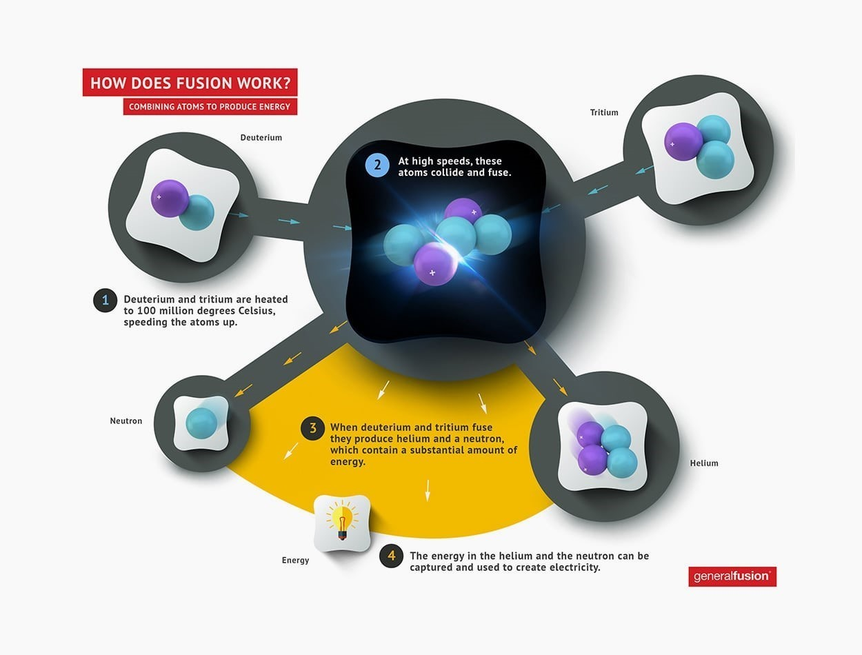

**Transport**

[Transport represents 23% of global energy-related CO2 emissions](http://www.worldbank.org/en/news/press-release/2016/05/05/leaders-call-for-global-action-to-reduce-transports-climate-footprint). But the demand for transport is only going to increase.

We have already found alternative ways of powering vehicles, such as with electricity, but in order to do it on a wide scale, we need much more efficient batteries and much more efficient battery-charging technology.

Researchers at the University of Surrey say they have made a [scientific breakthrough](http://www.surrey.ac.uk/mediacentre/press/2016/scientific-breakthrough-reveals-unprecedented-alternative-battery-power" \t "_blank) in this regard. They say they have discovered new materials offering an alternative to battery power and proven to be between 1,000-10,000 times more powerful than the existing battery alternative, a supercapacitor.

“The new technology is believed to have the potential for electric cars to travel to similar distances as petrol cars without the need to stop for lengthy recharging breaks of between 6 and 8 hours, and instead recharge fully in the time it takes to fill a regular car with petrol,” says the university.

**Food**

About a quarter of all global emissions come from feeding the world’s 7 billion people, and part of that comes from the consumption of meat. “There is no way to produce enough meat for 9 billion people,” [said Bill Gates in a 2013 blog post.](https://www.gatesnotes.com/About-Bill-Gates/Future-of-Food" \t "_blank)

One of the alternatives is to start producing lab-grown meat, and to produce meat substitutes that look, taste and feel like the real thing. It might seem like the stuff of science fiction, but companies and investors alike are taking it very seriously. The company [Beyond Meat](http://beyondmeat.com/), already supported by Bill Gates, has created the world’s first meat burger that is entirely plant based. It’s made mostly from vegetable protein found in peas.

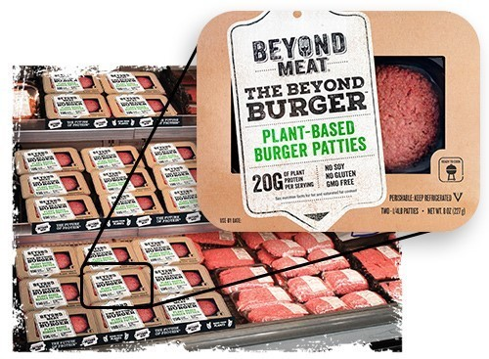

**Manufacturing**

Making the things we use every day puts an enormous strain on the climate – [about 30% of emissions come from industry.](http://www.b-t.energy/landscape/manufacturing/" \t "_blank)

But what if we could take those CO2 emissions out of the air? [Carbon Engineering](http://carbonengineering.com/" \t "_blank) is a Canadian start-up which is working on exactly that – taking carbon dioxide directly from the atmosphere and then using it to produce fuel.

According to the company, “direct air capture can remove far more CO2 per acre of land footprint than trees and plants”. The company is already running a demonstration plant in Squamish, British Columbia, that is removing one ton of CO2 from the air every day.

**Buildings**

The greenhouse gas emissions of buildings is also significant. We need lighting, power, heating and cooling whether at home or in the office, at school or in a hospital. The combined emissions from these sources contributes [almost 20% of global emissions](http://www.b-t.energy/landscape/buildings/" \t "_blank).

Part of the answer is to build smarter cities.

That's what a company called [Sidewalk Labs](https://www.sidewalklabs.com/" \t "_blank) (which is part of Alphabet Inc, the parent of Google) is doing, harnessing digital technologies to solve today’s pressing urban problems. One of their current projects involves [looking at how traffic flows through a city](http://www.nytimes.com/2016/03/18/technology/cities-to-untangle-traffic-snarls-with-help-from-alphabet-unit.html?_r=1" \t "_blank) and how hotspots of congestion might be solved. This could dramatically reduce air pollution in our cities.

Members of the Breakthrough Energy Coalition (BEC), which numbers among its members Jeff Bezos from Amazon, Jack Ma from the Ali Baba group and Richard Branson, have committed to investing more than $1 billion in new technologies over the next 20 years.

[Matt D'Avella](https://www.imdb.com/name/nm6576361/?ref_=tt_ov_dr): Netflix documentary: Minimalism, 2016, <https://www.netflix.com/title/80114460>

We will analyze the documentary using elements from this model: <https://docs.wixstatic.com/ugd/b7d215_97096a360a6f4d39b9fd7a45ff09749f.docx?dn=analyzing%20a%20Documentary.docx>