The Cash Boy  By Horatio Alger (1889)  http://www.online-literature.com/horatio-alger/cash-boy/9/ | 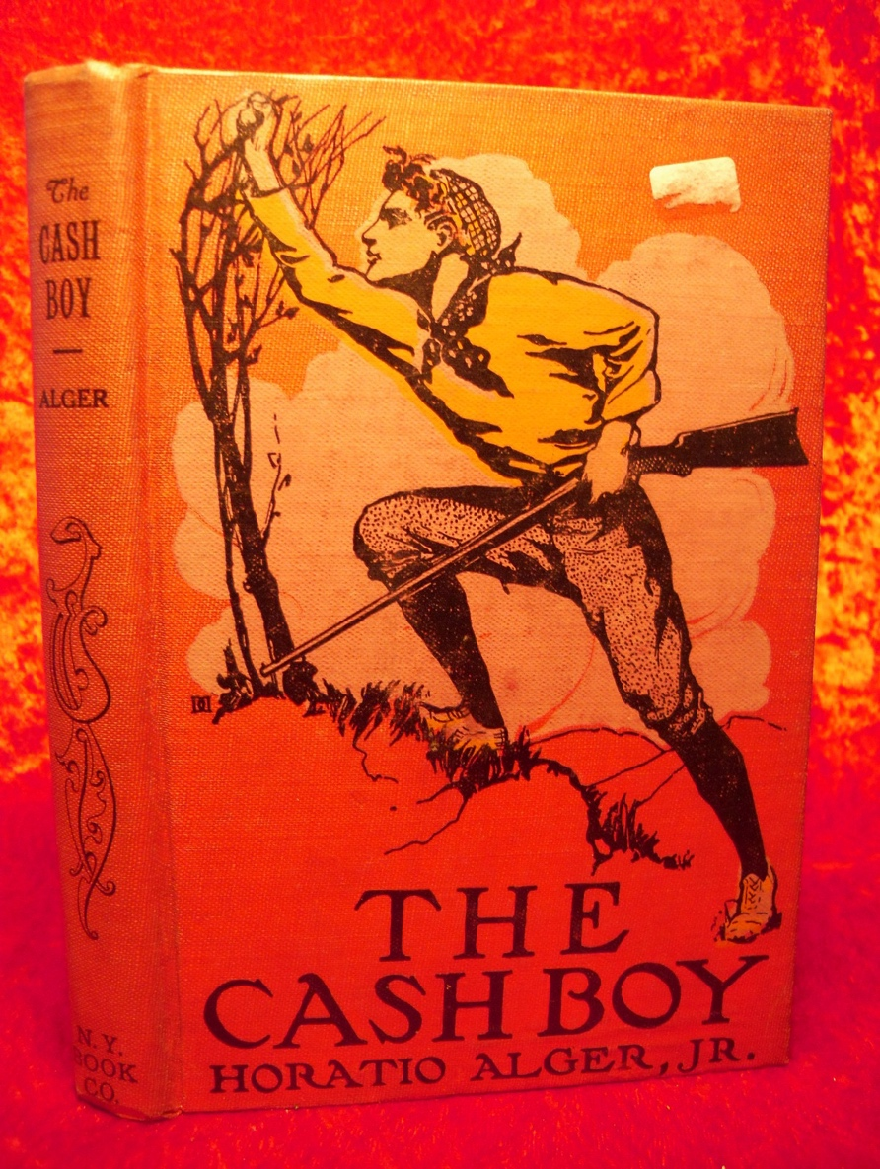

(Frank’s parents are dead and he has left for New York to provide for himself and his younger sister. He works as a cash boy in a retail establishment. His job is to run between the salesmen and the cashier)

» Chapter VII. The Cash Boy has an Adventure
--------------------------------------------------------------------------------
Four weeks passed. The duties of a cash-boy are simple enough, and Frank had no difficulty in discharging them satisfactorily. At first he found it tiresome, being on his feet all day, for the cash-boys were not allowed to sit down, but he got used to this, being young and strong.

All this was very satisfactory, but one thing gave Frank uneasiness. His income was very inadequate to his wants.

"What makes you so glum, Frank?" asked Jasper Wheelock one evening.

"Do I look glum?" said Frank. "I was only thinking how I could earn more money. You know how little I get. I can hardly take care of myself, much less take care of Grace."

"I can lend you some money, Frank. Thanks to your good advice, I have got some laid up."

"Thank you, Jasper, but that wouldn't help matters. I should owe you the money, and I don't know how I could pay you."

"About increasing your income, I really don't know," said Jasper. "I am afraid Gilbert & Mack wouldn't raise your wages."

"I don't expect it. All the rest of the cash-boys would ask the same thing."

"True; still I know they are very well pleased with you. Duncan told me you did more work than any of the rest of the boys."

"I try to do all I can."

"He said you would make a good salesman, he thought. Of course you are too young for that yet."

"I suppose I am."

"Frank, I am earning fifteen dollars a week, you know, and I can get along on ten, but of the five I save let me give you two. I shall never feel it, and by and by when you are promoted it won't be necessary."

"Jasper, you are a true friend," said Frank, warmly; "but it wouldn't be right for me to accept your kind offer, though I shan't forget it. You have been a good friend to me."

"And you to me, Frank. I'll look out for you. Perhaps I may hear of something for you."

Small as Frank's income was, he had managed to live within it. It will be remembered that he had paid but fifty cents a week for a room. By great economy he had made his meals cost but two dollars a week, so that out of his three dollars he saved fifty cents. But this saving would not be sufficient to pay for his clothes. However, he had had no occasion to buy any as yet, and his little fund altogether amounted to twenty dollars. Of this sum he inclosed{sic} eight dollars to Mr. Pomeroy to pay for four weeks' board for Grace.

"I hope I shall be able to keep it up," he said to himself, thoughtfully. "At any rate, I've got enough to pay for six weeks more. Before that time something may turn up."

Several days passed without showing Frank any way by which he could increase his income. Jasper again offered to give him two dollars a week out of his own wages, but this our hero steadily refused.

One Friday evening, just as the store was about to close, the head salesman called Frank to him.

"Where do you live?" he asked.

"In Sixth avenue, near Twenty-fifth street."

"There's a bundle to go to Forty-sixth street. I'll pay your fare upon the stage if you'll carry it. I promised to send it to-night, and I don't like to disappoint the lady."

"I can carry it just as well as not."

Frank took the bundle, and got on board a passing omnibus. There was just one seat vacant beside an old gentleman of seventy, who appeared to be quite feeble.

At Forty-fifth street he pulled the strap and prepared to descend, leaning heavily on his cane as he did so. By some mischance the horses started a little too soon and the old man, losing his footing, fell in the street. Frank observed the accident and sprang out instantly to his help.

"I hope you are not much hurt, sir?" he said, hastily.

"I have hurt my knee," said the old gentleman.

"Let me assist you, sir," said Frank, helping him up.

"Thank you, my boy. I live at number forty-five, close by. If you will lead me to the door and into the house I shall be much indebted to you."

"Certainly, sir. It is no trouble to me."

With slow step, supported by our hero, the old gentleman walked to his own door.

It was opened by a maid servant, who looked with some surprise at Frank.

"I fell, Mary," explained her master, "and this young gentleman has kindly helped me home."

"Did you hurt yourself much, sir?"

"Not seriously."

"Can I do anything more for you, sir?" asked Frank.

"Come in a moment."

Our hero followed his new acquaintance into a handsomely furnished parlor.

"Now, my young friend tell me if you have been taken out of your way by your attention to me?"

"Oh, no, sir; I intended to get out at the next street."

"My dinner is just ready. Won't you stop and dine with me?"

"Thank you, sir," he said, hesitatingly, "but I promised to carry this bundle. I believe it is wanted at once."

"So you shall. You say the house is in the next street. You can go and return in five minutes. You have done me a service, and I may have it in my power to do something for you in return."

"Perhaps," thought Frank, "he can help me to some employment for my evenings." Then, aloud:

"Thank you, sir; I will come."

Five minutes later Frank was ushered into a handsome dining-room. The dinner was already on the table, but chairs were only set for three. The one at the head of the table was of course occupied by the old gentleman, the one opposite by Mrs. Bradley, his housekeeper, and one at the side was placed for Frank.

"Mrs. Bradley," said the old gentleman, "this is a young gentleman who was kind enough to help me home after the accident of which I just spoke to you. I would mention his name, but I must leave that to him."

"Frank Fowler, sir."

"And my name is Wharton. Now that we are all introduced, we can talk more freely."

"Will you have some soup, Mr. Fowler?" asked the housekeeper.

She was a tall thin woman, with a reserved manner that was somewhat repellant. She had only nodded slightly at the introduction, fixing her eyes coldly and searchingly on the face of our hero. It was evident that whatever impression the service rendered might have made upon the mind of Mr. Wharton, it was not calculated to warm the housekeeper to cordiality.

"Thank you," he answered, but he could not help feeling at the same time that Mrs. Bradley was not a very agreeable woman.

"You ought to have a good appetite," said Mr. Wharton. "You have to work hard during the day. Our young friend is a cash-boy at Gilbert & Mack's, Mrs. Bradley.

"Oh, indeed!" said Mrs. Bradley, arching her brows as much as to say: "You have invited strange company to dinner."

"Do your parents live in the city, Frank--I believe your name is Frank?"

"No, sir; they are dead. My mother died only a few weeks since."

"And have you no brothers and sisters?"

"I have one sister--Grace."

"I suppose she is in the city here with you?"

"No, sir. I left her in the country. I am here alone."

"I will ask you more about yourself after dinner. If you have no engagement, I should like to have you stay with me a part of the evening."

"Thank you, sir."

Frank accepted the invitation, though he knew Jasper would wonder what had become of him. He saw that the old gentleman was kindly disposed toward him, and in his present circumstances he needed such a friend.

But in proportion as Mr. Wharton became more cordial, Mrs. Bradley became more frosty, until at last the old gentleman noticed her manner.

"Don't you feel well this evening, Mrs Bradley?" he asked.

"I have a little headache," said the housekeeper, coldly.

"You had better do something for it."

"It will pass away of itself, sir."

They arose from the dinner table, and Mr. Wharton, followed by Frank, ascended the staircase to the front room on the second floor, which was handsomely fitted up as a library,

"What makes him take such notice of a mere cash- boy?" said Mrs. Bradley to herself. "That boy reminds me of somebody. Who is it?"

Chapter VIII. An Unexpected Engagement
--------------------------------------------------------------------------------
"Take a seat, Frank," said Mr. Wharton, pointing to a luxurious armchair on one side of the cheerful grate fire; "I will take the other, and you shall tell me all about yourself."

"Thank you, sir," said our hero.

His confidence was won by Mr. Wharton's kind tone, and he briefly recounted his story.

At the conclusion, Mr. Wharton said:

"How old are you, Frank ?"

"Fourteen, sir."

"You are a brave boy, and a good boy, and you deserve success."

"Thank you, sir."

"But I am bound to say that you have a hard task before you."

"I know it, sir."

"Why not let your sister go to the poorhouse for a few years, till you are older, and better able to provide for her?"

"I should be ashamed to do it, sir," he said. "I promised my mother to take care of Grace, and I will."

"How much do you earn as a cash-boy?"

"Three dollars a week."

"Only three dollars a week! Why, that won't pay your own expenses!" said the old gentleman in surprise.

"Yes, sir, it does. I pay fifty cents a week for my room, and my meals don't cost me much."

"But you will want clothes."

"I have enough for the present, and I am laying up fifty cents a week to buy more when I need them."

"You can't buy many for twenty-six dollars a year. But that doesn't allow anything for your sister's expenses."

"That is what puzzles me, sir," said Frank, fixing a troubled glance upon the fire. "I shall have to work in the evenings for Grace."

"What can you do?"

"I could copy, but I suppose there isn't much chance of getting copying to do."

"Then you have a good handwriting?"

"Pretty fair, sir."

"Let me see a specimen. There are pen and ink on the table, and here is a sheet of paper."

Frank seated himself at the table, and wrote his name on the paper.

"Very good," said his host, approvingly. "Your hand is good enough for a copyist, but you are correct in supposing that work of that kind is hard to get. Are you a good reader?"

"Do you mean in reading aloud, sir?"

"Yes."

"I will try, if you wish."

"Take a book from the table--any book--and let me hear you read."

Frank opened the first book that came to hand-- one of Irving's and read in a clear, unembarrassed voice about half a page.

"Very good indeed!" said Mr. Wharton. "You have been well taught. Where did you attend school?"

"Only in the town school, sir."

"You have, at any rate, made good use of your advantages."

"But will it do me any good, sir?" asked Frank.

"People are not paid for reading, are they?"

"Not in general, but we will suppose the case of a person whose eyes are weak, and likely to be badly affected by evening use. Then suppose such a person could secure the services of a good, clear, distinct reader, don't you think he would be willing to pay something?"

"I suppose so. Do you know of any such person?" asked Frank.

"I am describing myself, Frank. A year since I strained my eyes very severely, and have never dared to use them much since by gaslight. Mrs. Bradley, my housekeeper, has read to me some, but she has other duties, and I don't think she enjoys it very much. Now, why shouldn't I get you to read to me in the evening when you are not otherwise employed?"

"I wish you would, Mr. Wharton," said Frank, eagerly. "I would do my best."

"I have no doubt of that, but there is another question--perhaps you might ask a higher salary than I could afford to pay."

"Would a dollar a week be too much?" asked Frank.

"I don't think I could complain of that," said Mr. Wharton, gravely. "Very well, I will engage you as my reader."

"Thank you, sir."

"But about the pay; I have made up my mind to pay you five dollars a week."

"Five dollars a week!" Frank repeated. "It is much more than my services will be worth sir."

"Let me judge of that, Frank."

"I don't know how to thank you, sir," said Frank, gratefully. "I never expected to be so rich. I shall have no trouble in paying for Grace's board and clothes now. When do you want me to begin reading to you?"

"You may as well begin to-night--that is, unless you have some other engagement."

"Oh, no, sir, I have nothing else to do."

"Take the Evening Post, then, and read me the leading editorial. Afterward, I will tell you what to read."

Frank had been reading about half an hour, when a knock was heard at the door.

"Come in," said Mr. Wharton.

Mrs. Bradley entered, with a soft, quiet step.

"I thought, sir," she began, "you might like me to read to you, as usual."

"Thank you, Mrs. Bradley, but I am going to relieve you of that portion of your labors. My young friend here is to come every evening and read to me."

"Indeed!" ejaculated the housekeeper in a tone of chilly displeasure, and a sharp glance at Frank, which indicated no great amount of cordiality. "Then, as I am intruding, I will take my leave." There was something in her tone that made Frank feel uncomfortable.

The Cash Boy, exercises (CLASS ACTIVITIES)

1) Give a summary of ‘The Cash Boy’

2) Analysis:

Context: Time
Place

Characters: Focus on the Cash Boy and his situation. Remember to substantiate your analysis

3) What can we learn about American values by analyzing ‘The Cash Boy’? You’ll need to go through all 6! Remember to substantiate your claims

freedom:
self-reliance:
equality of opportunity:
competition:
materialism:
hard work:

Verbets tider:
Skriv hvilke tider følgende sætninger benytter sig af og forklar skriftligt på dansk hvordan/hvorfor.

1: The duties of a cash-boy are simple enough

2: Small as Frank's income was, he had managed to live within it

3: By great economy he had made his meals cost but two dollars a week

4: “Where do you live?" he asked

5: "I fell, Mary," explained her master, "and this young gentleman has kindly helped me home."

6: "Now, my young friend, tell me if you have been taken out of your way by your attention to me?"

7: You have done me a service

8: However, he had had no occasion to buy any as yet, and his little fund altogether amounted to twenty dollars.

9: "You are a brave boy, and a good boy, and you deserve success."

10: You have been well taught.

Der er fejl i tiderne på følgende sætninger. Forklar fejlene.

1: Small as Frank's income was, he has managed to live within it

2: "I fell, Mary," explained her master, "and this young gentleman had kindly helped me home."

3: "Now, my young friend, tell me if you had been taken out of your way by your attention to me?"

4: However, he had no occasion to buy any as yet, and his little fund altogether amounts to twenty dollars.

