11 Facts about the United States - Find kongruensfejlene

- The USA is a country on the North American continent that consist of 50 states, a federal district (District of Columbia) and 14 territories.

- 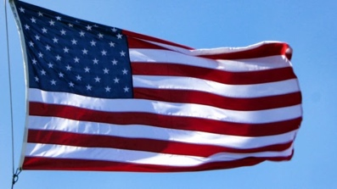The national flag of the USA have 13 stripes and 50 white stars on a blue background. The 13 stripes refers to the 13 British colonies that declared independence from the kingdom of Great Britain in 1776 and the 50 stars refer to the 50 U.S. states.

- The motto of the USA are ‘In God We Trust’.

- The anthem of the USA are called 'Star-Spangled banner' and the lyrics is based on a poem by Francis Scott Key in 1814.

- The capital city of the USA is called Washington D.C. D.C. stand for District of Columbia. Washington D.C. have about 7.5 million inhabitants.

- The USA share land borders with Canada and with Mexico. The border shared with Canada are the longest international border in the world. It is 8,891 km/ 5,525 miles long. The other international border of the USA with Mexico is 3,145 km/ 1,954 miles long.

- The USA is the third largest country in the world. The USA is smaller than Russia or Canada, but larger than China, if all territories as well as coastal and territorial waters is included.

- The USA is the third most populous country in the world after China and India. The USA is home to 330 million inhabitants. Almost 40% of all Americans lives close to the East Coast states, while about 16% live along the West Coast states. 83% of the population lives in urban areas.

- The largest city in the USA is New York, 8.4 million people inhabits the city.

-  New York city have been home to many of the most famous rappers of all time.

- Find dit eget fact om USA og skriv det ned med en kongruensfejl.

